**Math 120**

**Test 2D**

**Student Name: _______________________________________ Student Number: ______________________**

**Directions:**

* SHOW ALL YOUR WORK OR JUSTIFICATION FOR ANSWERS *ON THE TEST*. Scrap paper is sometimes hard to read and I want to give you partial credit!
* Simplify all answers.
* Round answers as indicated.
* Include units with final answers.

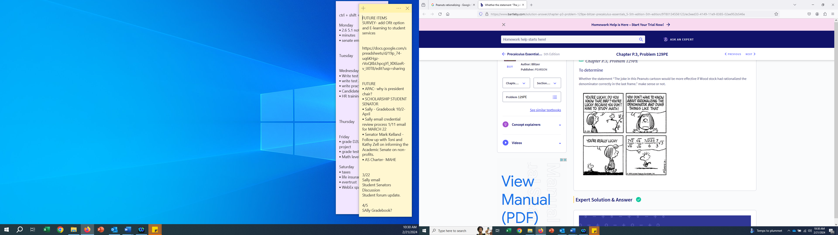

BRAIN DRUMP AREA:

* 1. Decide whether each of the following statements makes sense (is clearly true) or does not make sense (is clearly false). Fill in the right side of the table in each line with *True* for makes sense or with *False* for does not make sense. (5 points)

|  |  |
| --- | --- |
| **Statement** | **True (makes sense) or False (does not make sense)** |
| To get rid of fractions in a linear equation you must multiply every term on both sides by a common denominator (usually the lowest one) |  |
| The zeros of a function refer to when f(x)=0 which is where the function meets the x-axis if they are real numbers |  |
| To divide complex numbers, you must multiply the numerator and denominator by the conjugate of the numerator |  |
|  |  |
| The two restrictions to check for when looking for domain in this class are denominator ≥ 0 and radicand ≠ 0 |  |

* 1. Solve the linear equations. (4 points)
     1. b.

a.________________ b.________________

* 1. Use the conditions to solve the linear equation.

1. Suppose and . Find all *x* values such that . (2 points)

a.______________________

1. Suppose and . Find all *x* values such that . (3 points)

b.______________________

* 1. Use the following rational equation. (5 points)



a. Identify any excluded values. a.____________________

b. Solve the rational equation. Do not include values that are excluded, when applicable.

b.__________________

* 1. Use the following rational equation. (5 points)

a. Identify any excluded values. a.____________________

b. Solve the rational equation. Do not include values that are excluded, when applicable.

b.____________________

* 1. For Mixed Martial Arts (MMA) two fighters train differently, but over time their weekly training hours start to change. (6 points)

a. One fighter started out training **12 hours per week,** but as they got more serious about competing, they increased their training by **4 more hours each week.** Write a function that models how many hours they train after *x* weeks.

______________________

b. Another fighter started off training only 1**8 hours per week,** but as they became more dedicated, they increased their training by **3 hours per week.** Write a function that models how many hours they train after *x* weeks.

______________________

c. After how many weeks will both fighters be training the same number of hours per week? Include units.

______________________

d. For that week, how many hours will each fighter be training? Include units.

______________________

e. How many hours will the first fighter be training at 10 weeks? Include units.

______________________

* 1. You love to read and recently found the full Harry Potter series available to buy! You paid $166.41 for the entire series with matching trunk box. If Michigan has a 6% sales tax, find the cost of the Harry Potter series before the MI sales tax. Interpret your answer in a complete sentence within the context of the question. (4 points)

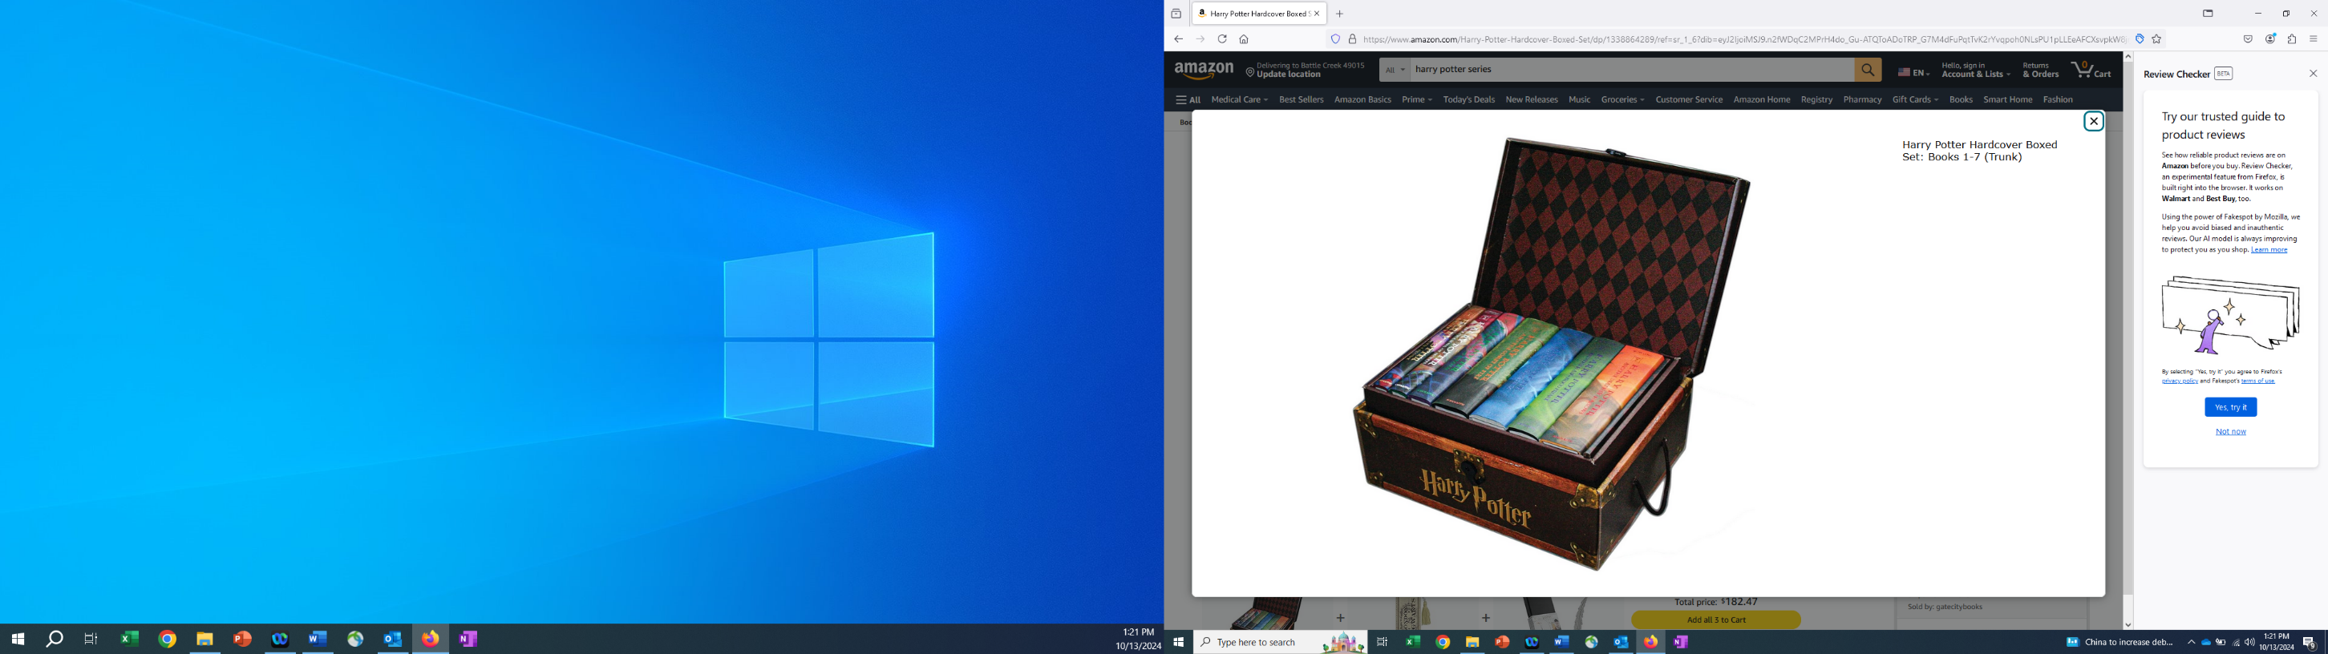

_______________________________________________________

_______________________________________________________

_______________________________________________________

_______________________________________________________

* 1. In 2020 there were two TikTok influencers Dr. Spencer Reid and Penelope Garcia. Dr. Reid started with 600,000 followers and increased each year by 40,000 followers per year. Penelope started with 1,000,000 followers but got canceled for a scandal with her coworker Derek Morgan and has been losing 60,000 followers per year. (5 points)

a. Let *x* represent the number of years since 2020. Write (DO NOT SOLVE) an equation that can be used to find how many years after 2020 that Spencer Reid and Penelope Garcia will have the same number of influencers.

__________________________________________________________

b. The following table is based on your equation from part *a*. Y1 represents one side of the equation and Y2 represents the other side of the equation.

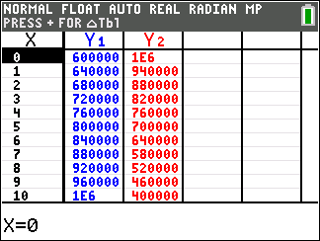

Use the table to answer these questions: In WHAT YEAR will the TikTokers have the same number of followers? What will the number of followers be in that year?

Year_____________________________

Number of Followers_____________________________

* 1. Solve the following inequalities. Other than no solution, use interval notation to express solution sets and graph each solution set on a number line. (4 points)

a. b.

a. __________________ b. __________________

* 1. Solve the following inequalities. Other than no solution, use interval notation to express solution sets and graph each solution set on a number line. (4 points)

a. 

a. __________________

b. Suppose that and . On what interval is 

b. __________________

* 1. You are deciding between two taco options for a small party. The Taco Truck charges a $50 setup fee and $5 per taco. The Taco Stand charges a $30 setup fee and $7 per taco. How many tacos must you order for the Taco Truck to be the *better deal* over the Taco Stand? Interpret your answer in a complete sentence within the context of the question. (5 points)

__________________________________________________________________________________________

__________________________________________________________________________________________

__________________________________________________________________________________________

* 1. Solve the system of linear equations by the method of your choice. (6 points)

a.  b. 

a. __________________ b. __________________

13. In February of 2024 AT&T cellphone coverage went down all across the world! Students in class freaked out because they couldn’t Snap their friends! Many cellphone users were annoyed while Boomers were praising that they still had their land lines. The function models the number of land-line customers in the US, in millions, *x* years after 2000. The function models the number of cellphone customers, in millions, *x* years after 2000. (6 points)

a. Determine the year when the number of cellphone customers and land line customers was the same. Round to the nearest year.

______________________

b. Using your ROUNDED answer, how many millions of cellphone customers were there for this ROUNDED year?

______________________

14. Perform the operations as indicated. Put your answer in standard form a+b*i*. (6 points)

a. __________________

1. __________________
2. __________________

15. Perform the operations as indicated. Put your answer in standard form a+b*i*. (4 points)

a. b.

a. __________________ b. __________________

16. Perform the operations as indicated. Put your answer in standard form. (6 points)

a.  b. 

a. __________________ b. __________________

17. For each quadratic equation, pick the most *efficient* method for solving the equation. Circle one option. DO NOT SOLVE. (5 points)

a.  Square root property Factoring Quadratic Formula

b.  Square root property Factoring Quadratic Formula

c.  Square root property Factoring Quadratic Formula

d.  Square root property Factoring Quadratic Formula

e.  Square root property Factoring Quadratic Formula

18. Solve the following quadratic equations using any method of your choice. Give the EXACT answer. (6 points)

a.  b. 

a. __________________ b. __________________

19. The graph of the quadratic function  follows (4 points):

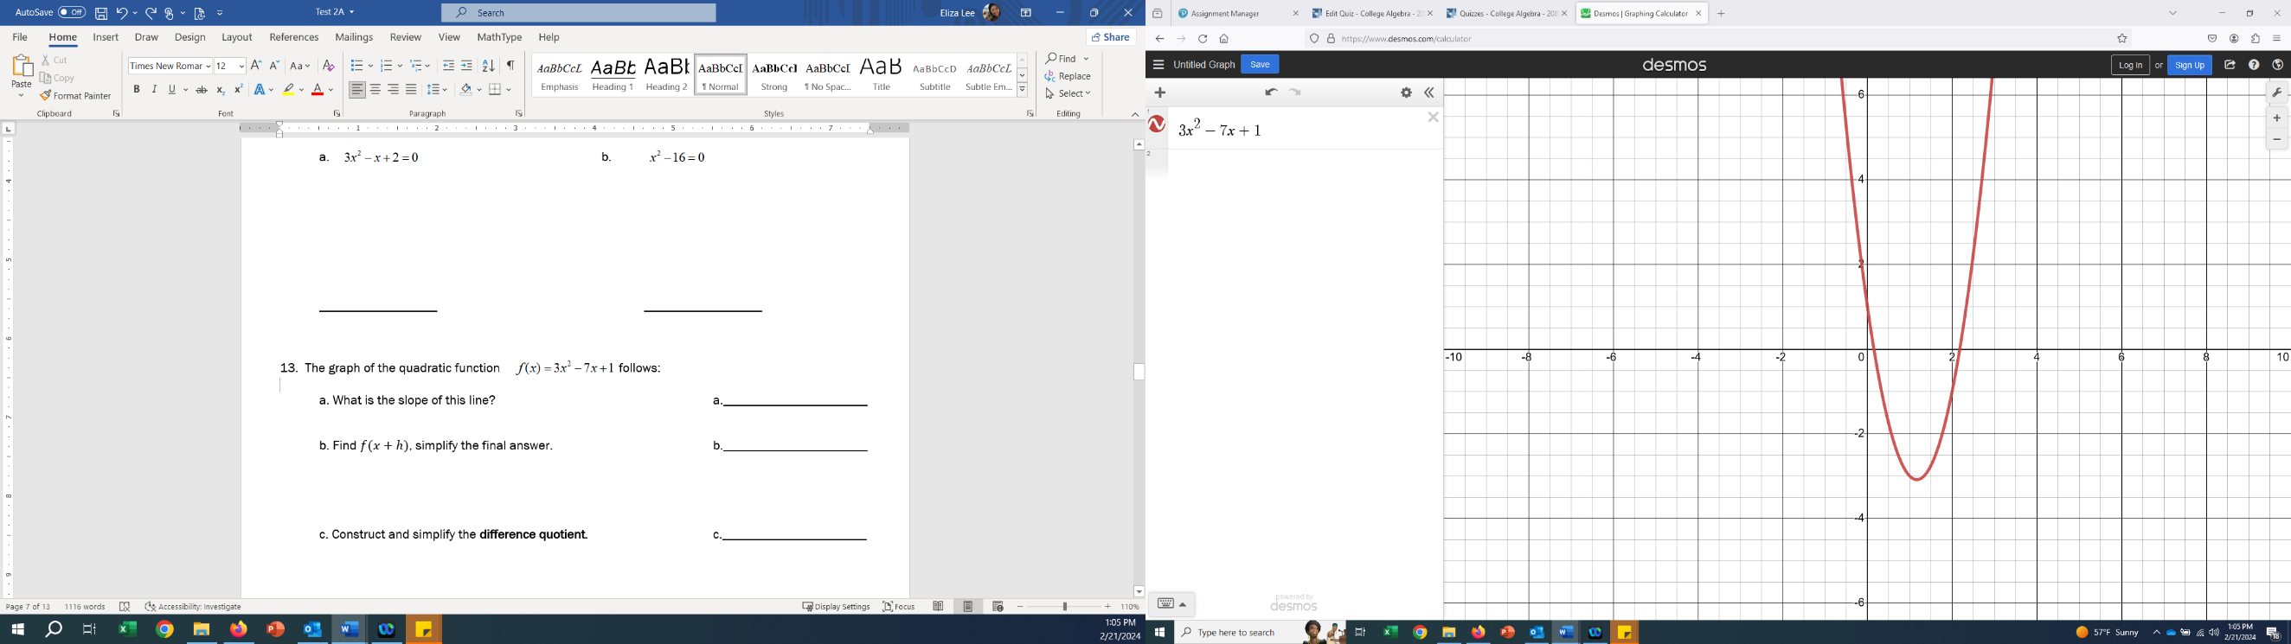 a. Identify the zeros by plotting the points DIRECTLY onto the graph.

b. The zeros plotted are irrational (cannot be expressed as a fraction or whole number). Find the EXACT values of the zeros for the function.

__________________

20. Oh no! There has been a big storm and a tree has fallen. The 25-foot tree is leaning against your house. The base or trunk of the tree missed your sidewalk and is 6 feet from the bottom of your house. If the tree reaches the top of the flat roof, how tall is your house? Round to the nearest foot. DRAW A PICTURE to help you. (5 points)

_____________________

OPTIONAL EXTRA CREDIT QUESTION:

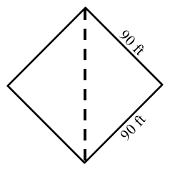Spring Training has started for the Detroit Tigers Major League Baseball team. One of the catchers, Jake Rogers, was complaining to first baseman Spenser Torkelson that he has to throw farther to second base than Torkelson does. Jake Rogers says “Throwing from home base to second base is farther than throwing from first base to second base.” Is Jake Rogers right? How far is it from home base to second base? Round to the nearest hundredth of a foot. Interpret your answer in a complete sentence within the context of the question.



__________________________________________________________________________________________

__________________________________________________________________________________________

__________________________________________________________________________________________

**Formula Sheet: Math 120**

**Straight Line**

Slope Intercept form Point-slope form Slope

  

**Difference Quotient Quadratic Formula**

 

**Logarithms**

  

**Distance**:  **Midpoint**: 

**Circle**: 

**Quadratic Function**

, Vertex =  , Vertex = 

**Compound Interest**:  **Continuous Compound Interest:** 

**Arithmetic Sequence Geometric Sequence**

 Finite:  

 Infinite: , 

**Even function Odd function**

 